ARS – eCommerce integration

Release Notes

# Revisions

|  |  |  |  |
| --- | --- | --- | --- |
| **Revision** | **Date** | **Author** | **Description** |
| 1.0 | 30/03/2021 | Simone Sambruni | Initial Draft |

# Table of Contents

Revisions 2

Table of Contents 3

1 Overview 1

2 Purpose 2

3 Issue Summary 3

3.1 As@r / Ars Pos 3

3.1.1 Feature overview 3

3.1.2 Configuration 3

3.1.3 Java classes 4

3.2 eCommerce ARS Interface Web Services 5

3.2.1 Feature overview 5

3.2.2 Configuration 5

3.3 Database 6

3.3.1 Tables 6

3.3.2 Diagram 6

3.4 Test cases 7

# Overview

This document describes the content of release about ARS – Ecommerce Integration development.

About functionality specification refer to document **2020-003 TSC eCommerce integration v1.10**.

# Purpose

This release is composed by:

* As@r / Ars Pos Java version 3.01.1.8.02 date 29-03-2021
* eCommerce ARS Interface Web Services version 1.0.0
* Database

# Issue Summary

## As@r / Ars Pos

### Feature overview

The following mechanisms have been implemented in the Pos:

* Polling request to the WS to retrieve new baskets that will be processed as POS transactions.
* Manage of additional receipt printing with extra data.
* Heartbeat message send to WS every X seconds with pos informations.

### Configuration

Added two configuration files on config directory for the Ecommerce development:

* **Ecommerce.properties**

*Enable Ecommerce functionality on As@r ARS Pos*

**enabled=true**

*Url of rest request for basket polling*

**url=https://localhost:44335/api/Basket**

*Timeout of WS comunication*

**timeout=60**

*Connection Protocoll type*

**protocol=https**

*Indicate if it’s possible procede with automatic payment*

**finalize = true**

*Indicate the possible tenders and one of default for automatic payment.*

**tender.Online=01**

**tender.Credit=11**

**tender.Default=01**

*Indicate if Issue warning if some items haven't been sold*

**notSoldWarning=false**

*Indicate the delay of HeartBeat signal send to WS*

**heartBeatSignal=5000**

*Indicate the total receipt copies and additional text line to print*

**printedCopiesNumber=4**

**printedCopies.1.Text=CUSTOMER COPY**

**printedCopies.2.Text=CUSTOMER COPY**

**printedCopies.3.Text=DRIVER COPY**

**printedCopies.4.Text=STORE COPY**

* **Hearbeat.properties**

*Url of rest request for hearbeat signal*

**url=https://localhost:44335/api/Heartbeat**

*Timeout of WS comunication*

**timeout=5**

*Connection Protocoll type*

**protocol=https**

Update the configuration file EVENT.TBL including:

***{/*074*/0xabcd, 73, 73,0x05, 0, 0, 0, 0,180/*start ecommerce*/}***

In this release is also include Surchange functionality; update the configuration

file PREGPAR.DAT including:

**SCPP0:0100000000000000000000000000000000000000**

About functionality specification refer to document **POS_Surcharge_Functionality.doc**

### Java classes

Added the following new classes into AS@R / ASR project:

* Basket.class
* HeartBeatTimerTask.class
* Item.class
* TerminalItem.class
* HttpClient.class
* HttpClientFactory.class
* HttpsClient.class
* IHttpClient.class
* EcommerceManager.class

## eCommerce ARS Interface Web Services

### Feature overview

The following Rest request have been implemented into Web Services:

* Basket Request (PUT)
* Basket Polling (GET)
* Basket Update (POST)
* Basket Erase (DELETE)
* Status Update (POST)
* Status Polling (GET)

### Configuration

A parameter is present into the Web.config:

*Indicates the time after which the pos's status are updated to "unreachable".*

**<appSetting>**

**<add key=”HBTimeIsOver” value=”60” />**

**</appSetting>**

## Database

### Tables

Created the following table:

* DATA_BASKET
* DATA_ITEM
* DATA_SOLDITEM
* DATA_NOTSOLDITEM
* DATA_TERMINAL

### Diagram

Following the database diagram with relationships:

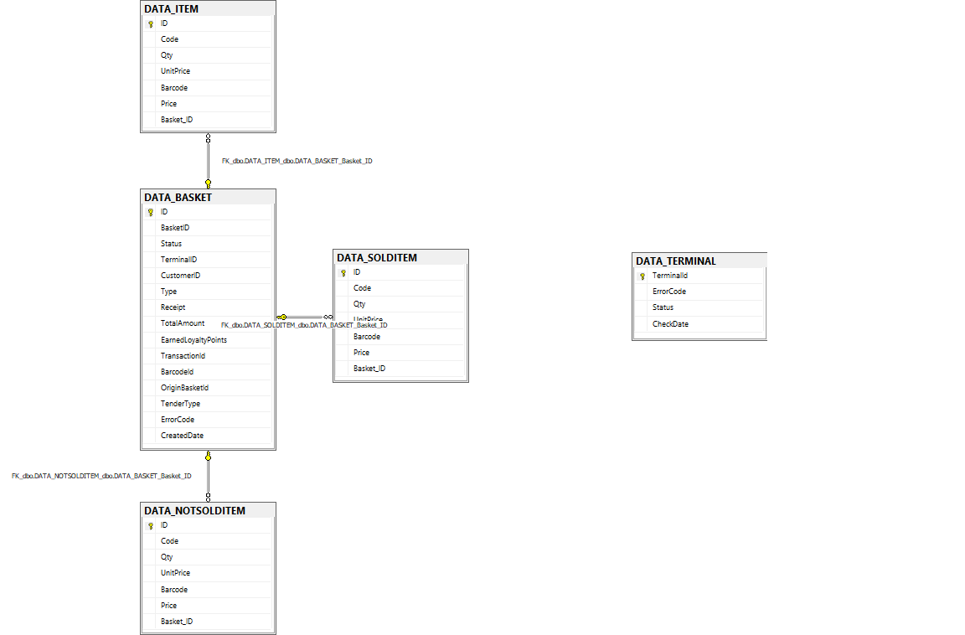

## Test cases

The list of tests executed is the following:

* As@r execute the polling eCommerce ARS Interface
* As@r receives basket and performs a transaction with automatic Payment
* Testing print of receipt copies as per configuration
* As@r receives basket, does not contain Payment Information
* Case of a return Transaction
* E-commerce receives ARS receipt
* Basket update by POST request
* Erase Basket by DELETE request
* POS has errors (es. Printer error)
* Status Update (POST) –ARS POS to update eCommerce interface on status.
* Heartbeat - Every X second all ARS POS configured as eCommerce POSes send a POST message to Heartbeat WS in eCommerce interface.
* Response to Hearbeat and Check status.
* ECommerce generates basket and invokes PUT method - no answer is returning (HTTP timeout).
* ECommerce generates basket and invokes PUT method - answer is returned with error 400.

N.B.

All tests about eCommerce ARS Interface was done by Postman tool

(in the zip file there is a postman collection file)